Internet telephony is a thing that nowadays almost everyone must use. I use a lot of internet telephony apps. Mostly Microsoft Teams for work and school, Discord for playing games with friends and Skype for business for business calls.   
I think that internet telephony is a nice invention because everyone is always available, and you don’t have to get the telephone number of another person. It is enough to know their name.

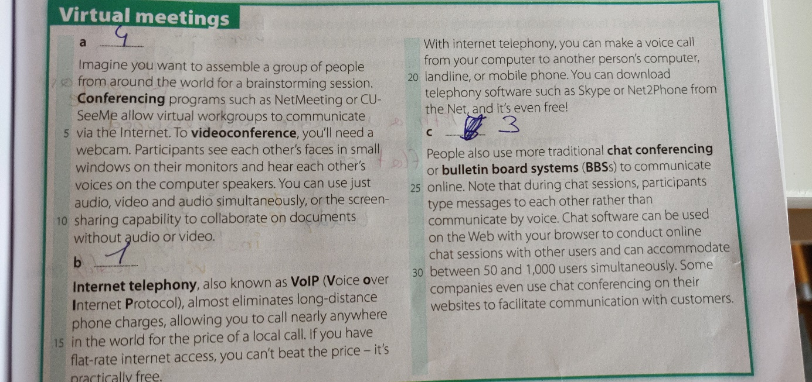I already had a lot of virtual meetings. Because I work in such a big company and we have people working all over the globe. We can’t always meet up at a physical place, so we use applications like Skype and Microsoft Teams a lot.

